|  |  |
| --- | --- |
| Team ID | PNT2022TMID07522 |
| Project Name | Smart farmer-IOT Enabled smart farming application |

AN ACCOUNT WAS CREATED IN MIT APP INVENTOR AND FEATURES WERE OVERVIEWED

DESIGNER

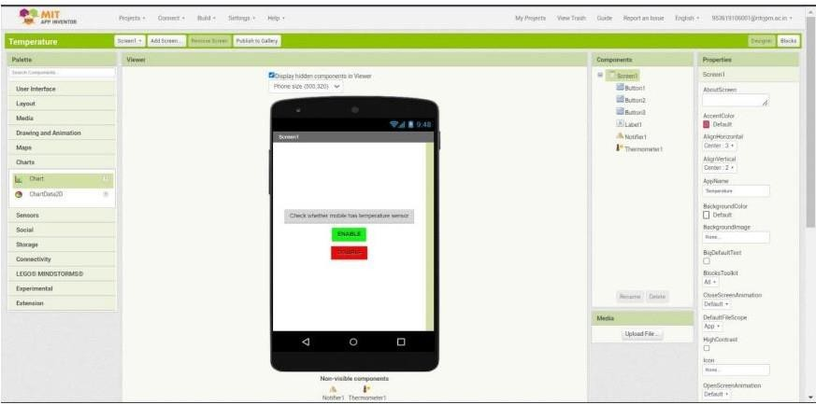

BLOCKS

